Final Paper:

Kimball Data Warehouse Architecture

versus

Inmon Data Warehouse Architecture

Arin Zargarian

COMP 440 - Database Design

Professor Yevgeniya Genchikmakher

May 18, 2107

**Abstract**

Successful organizations should make good decisions. And making good decisions requires all relevant data to be taking into consideration. The best source for that data is a well-designed data warehouse. Many organizations today need to create data warehouses for decision support. To create the data warehouse they face a range of choices, both in terms software tools and development approaches. This requires understanding of two main data warehousing architectures. Inmon and Kimball data warehousing models are the two most commonly discussed methods. Debates on which method is better and more effective have been on for years, both philosophies have their advantages and disadvantages. Enterprises continue to use either of these architectures successfully or even both models as a hybrid solution (Breslin, 2004).

In this paper, I compare Inmon and Kimball architectures by providing the similarities, differences, and influential factors favoring each approach, following the guidelines to determine a suitable approach based on the requirements and the organizational culture and expectations.

**What I Learned From Industry’s Papers**

Bill Inmon is the father of the Data warehousing. He introduced his seminal work of building Data Warehousing in early1990s. His methodology very soon began to be implemented in many fields. In 2002 Inmon released a new edition of his work, “A logical architecture that extracts detailed, time-stamped data form disparate operational database” (George, 2012). In this model the data extracts from this monolithic data warehouse and create smaller, departmental databases. Inmon uses Top-down structure for his data warehouse.

At the same time Ralph Kimball who was a database expert began to create new model of data warehouse. In 1996 he published “The Data Warehouse Toolkit”. In the last version of his work he announced architecture of multiple database also known as data marts (Kempe, 2012). His development and methodology was unique for data warehousing. The philosophy of Kimball is Bottom-up approach that is significantly different from Inmon’s architecture.

Inmon defines data warehouse as a centralized repository for the entire enterprise. Data warehouse stores the “atomic” data at the lowest level of detail. Dimensional data marts are created only after the complete data warehouse has been created. Thus, data warehouse is at the center of the Corporate Information Factory (CIF), which provides a logical framework for delivering business intelligence. “Inmon defines the data warehouse in the following terms: **1. Subject-oriented:**The data in the data warehouse is organized so that all the data elements relating to the same real-world event or object are linked together. **2.** **Time-variant:**The changes to the data in the database are tracked and recorded so that reports can be produced showing changes over time. **3.** **Non-volatile:** Data in the data warehouse is never over-written or deleted; once committed, the data is static, read-only, and retained for future reporting. **4.** **Integrated:** The database contains data from most or all of an organization's operational applications, and that this data is made consistent” (George, 2012).

Ralph Kimball, on the other hand, suggests a bottom-up approach that uses dimensional modeling, a data modeling approach unique to data warehousing. Rather than building a single enterprise-wide database, Kimball suggests creating one database (or data mart) per major business process. Enterprise-wide cohesion is accomplished by using another Kimball innovation, a data bus standard (Breslin, 2004).

As discussed earlier Inmon and Kimball have different approaches. Inmon start building a large centralized enterprise-wide data warehouse. To serve the analytical needs of department Inmon need to use several satellites that later became popular as data marts. This kind of approach is known as top-down. But Kimball methodology was much different than Inmon; he started by building several data marts that can serve the analytical needs of departments. Which can have followed by “vitality” integrating these data marts for consistency through an “information bus”, and its famous as bottom-up approach. The major difference of Inmon and Kimball structures: Inmon believe in creating a relational model (3NF), however Kimball uses the multi-dimensional modeling (star-schema and snowflake). Inmon argue that if we use the relational model, we will attain the enterprise-wide consistency. Therefore, we make the spawn-off much easier than the data marts in dimensional models. On the other hand, Kimball argues that the professional users will understand, analyze, aggregate, and explore data inconsistencies in an easier way if the data is structured in multi-dimensional model. In the multi-dimensional all information categorized in a better way and it is much faster to use. However, both architectures believe in separation of detailed level data form from aggregated level data (Breslin, 2004).

**Comparison of Essential Features of Inmon’s and Kimball’s Models (Breslin, 2004):**

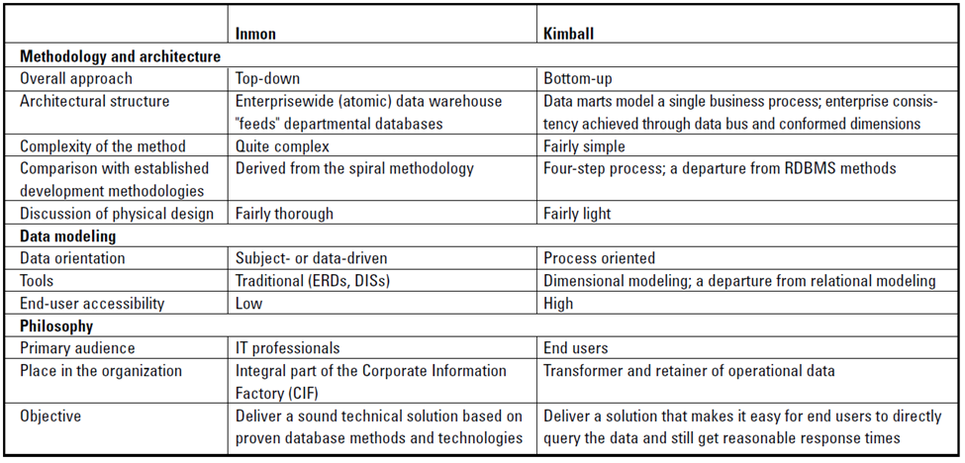

**Deciding Factors**

Data warehouse architects need to decide between the Kimball and Inmon approaches every time they start building a data warehouse. I listed the deciding factors that can help an architect to choose between two methods.

**Reporting Requirements:** If the reporting requirements are strategic and enterprise-wide and integrated reporting is needed, then Inmon works best. If the reporting requirements are tactical and business process oriented or team oriented, then Kimball works best.

“**Project Urgency**: If the organization has enough time to wait for the first delivery of the data warehouse (4 to 9 months), then Inmon approach can be followed. If there is very little time for the data warehouse to be up and running (2 to 3 months) then the Kimball approach is more suited.

**Future Staffing Plan:** If the company can afford to have a large sized team of specialists to maintain the data warehouse, then the Inmon method can be pursued. If the future staffing plan for the team is to be thin, then Kimball is more suited.

**Frequency of Changes:** If the reporting requirements are expected to change more rapidly and the source systems are known to be volatile, then the Inmon approach works better, as it is more flexible. If the requirements and source systems are relatively stable, the Kimball method can be used.

**Organization Culture**: If the sponsors of a data warehouse and the managers of the firm understand the value proposition of the data warehouse and are willing to accept long-lasting value from the data warehouse investment, the Inmon approach is more suited. If the sponsors do not care about the concepts but require a solution to get better at reporting, then the Kimball approach is more suited” (Breslin, 2004).

**Conclusion**

Both the Inmon and Kimball approach work successfully for delivering data warehouses. Some organizations have implemented a combination of both which is called “hybrid model”. In a hybrid model, the data warehouse is built using the Inmon model, and on top of the integrated data warehouse, the business process oriented data marts are built using the star schema for reporting. We cannot generalize and say that one approach is better than the other; they both have their advantages and disadvantages, and they both work fine in different scenarios. The architect of a data warehouse should select an approach for the data warehouse depending on different factors; a few key factors were identified in this paper. Finally, for any approach to be successful, it needs to be discussed in detail, designed to satisfy the organization’s BI reporting needs and should also be suitable with requirements and the culture of the organization.

**References:**

Breslin, Mary. "Data Warehousing Battle of the Giants: Comparing the Basics of the Kimball and Inmon Models". *Business Intelligence Journal*. Winter, 2004, pp. 6-20.

George, Sansu. "Inmon vs. Kimball: Which Approach Is Suitable for Your Data Warehouse?" *ComputerWeekly*. April 2012. http://www.computerweekly.com/tip/Inmon-vs-Kimball-Which-approach-is-suitable-for-your-data-warehouse. Accessed 5 May 2017.

Kempe, Shannon. "A Short History of Data Warehousing." *DataVersity*. 23 August 2012. http://www.dataversity.net/a-short-history-of-data-warehousing. Accessed 11 May 2017.

Singh, Mukesh. "Inmon vs. Kimball Data Models Approaches." *Microsoft Business Intelligence Data Tools*. 28 September 2016. http://www.sql-datatools.com/2016/09/inmon-vs-kimball-data-warehouse-Architecture-approaches.html. Accessed 5 May 2017.